RESOLUTION NO.__________

RE: CERTIFICATE OF APPROPRIATENESS UNDER THE
PROVISIONS OF THE ACT OF THE PENNSYLVANIA
LEGISLATURE 1961, JUNE 13, P.L. 282 (53
SECTION 8004) AND BETHLEHEM ORDINANCE NO.
3952 AS AMENDED.

WHEREAS, it is proposed to move the existing sign from 817 E. Fourth Street to 826 E. Fourth Street.

NOW, THEREFORE, BE IT RESOLVED by the Council of the City of Bethlehem that a Certificate of Appropriateness is hereby granted for the work.

Sponsored by: (s)

(s)

ADOPTED BY COUNCIL THIS DAY OF

(s)
President of Council

ATTEST:

(s)
City Clerk

HISTORIC CONSERVATION COMMISSION

CASE # 549 – It is proposed to move the existing sign from 817 E. Fourth Street to 826 E. Fourth Street
OWNER/APPLICANT: First Hispanic Baptist Church of Bethlehem / Edeline Chouloute

The Commission upon motion by Mr. Loush seconded by Mr. Cornish adopted the proposal that City Council issue a Certificate of Appropriateness for the proposed work described herein:
- The proposal to move the existing sign from 817 E. Fourth Street to 826 E. Fourth Street was presented by Edeline Chouloute.
- The existing sign reads “Dynamic Kidz Academy Daycare” and is approximately 48” x 18” in size.
- The sign will be located over the window to the left of the entrance to 826 E. Fourth St. It will be centered vertically between the first and second floors. The sign will also center, horizontally, on the windows.
- The proposed motion was unanimously approved.

CU: cu
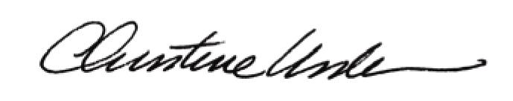

By:

Date of Meeting: May 18, 2015 Title: Historic Officer

